Pacific Salmon Commission

600 – 1155 Robson Street
Vancouver, BC
V6E 1B5
604-684-8081 (Phone)
604-666-8707 (Fax)

Fish Identification
This guide is designed to help you in identifying adult salmon. If further clarification is required, please do not hesitate to contact Fisheries & Oceans Canada, or the Pacific Salmon Commission for assistance.

Contact:

Fisheries & Oceans Canada – Regional Offices

OR

Zac Semeniuk, Sampling Coordinator
Phone: 604-684-8081 ext. 612
Fax: 604-666-8707
Email: semeniuk@psc.org
Chinook
Adult Chinook Salmon – Ocean Phase
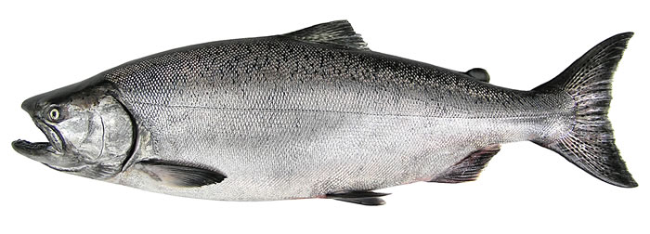
Distinguishing Characteristics:
- Black mouth with black gums
- Large, sharp teeth on upper and lower jaw
- Large irregular spots on back
- Distinctive spots on upper and lower portions of the tail
Chinook
Adult Chinook Salmon – Mouth and Tail
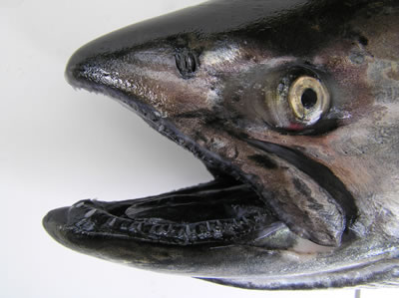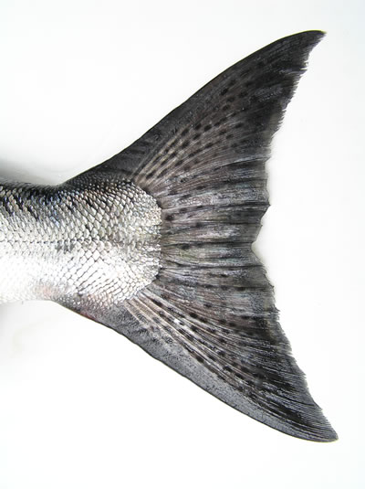
Sockeye
Adult Sockeye Salmon – Ocean Phase
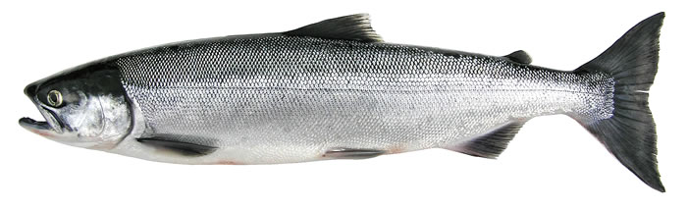
Distinguishing Characteristics:
- Light mouth with light gums
- Very small teeth on upper and lower jaw
- No spots on back or tail
- Large, glassy eye

Sockeye
Adult Sockeye Salmon – Mouth and Tail
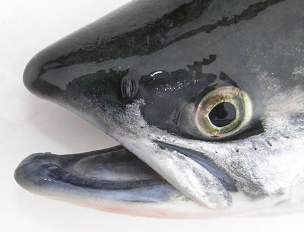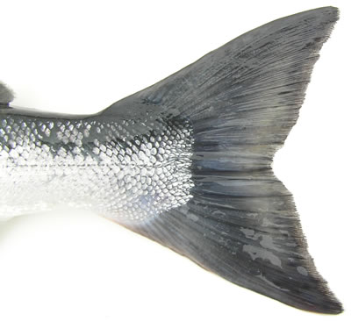

Coho
Adult Coho Salmon – Ocean Phase
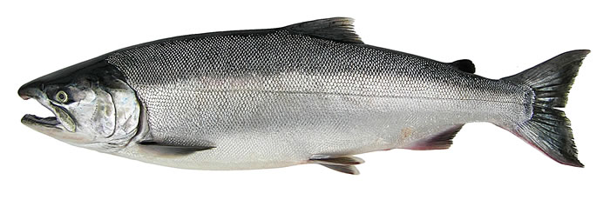
Distinguishing Characteristics:
- Dark mouth with white gums
- Large, sharp teeth on upper and lower jaw
- Few spots on back and upper half of tail
- Broad caudal peduncle

Coho
Adult Coho Salmon – Mouth and Tail
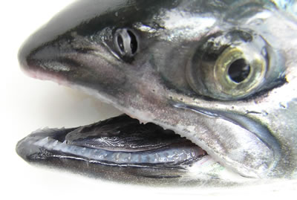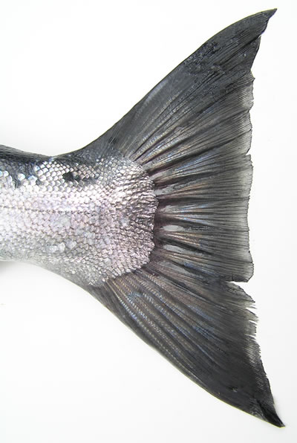

Steelhead
Adult Steelhead – Ocean Phase
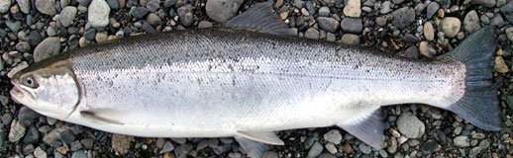

Distinguishing Characteristics:
- Light mouth with white gums
- Teeth on upper and lower jaw
- Heavy spotting on back and tail
- Broad caudal peduncle
- Square shaped tail

